MS/WT Power Platform Weekly Connect (Rafael)

Wednesday, October 26, 2022

11:59 AM

**Regarding Granting/Removing User Access to App**

* Something breaks on medical side, more catastrophic
  + If it's on corporate side, it's more resolvable, but medical issues interrupt ability to care for patients
  + Is there way to have a flow, maybe app, flow, to allow user to come in and request access for app inside WTE environment directly frm default env
  + Use trigger, PA flow? That will automatically add them to group
    - You want to only lock it down
    - Share it only with group, not with KP
    - Users might not be part of 10000 group, might want to req access
    - Want to host app on default env
    - Why do you want to host on default env if you can host on name? env.
    - What data source being used?
      * Only using Sharepoint
    - If user wants to use app, do they need to be added to share point list -> No.
  + Second app has self-center
    - Can people just add themselves to the gorup or need approval. What stops normal users from requesting access?
    - Request itself doesn't need approval
      * If need access, user is added to security group, app is auto shared, and they can begin testing
      * Can be done, Have app trigger flow with a button
        + Add user to the group, then share app with group instead of sharing individually with the user

* We don't have list of users, anticipating 10k users, don't have tracking mech, just post app link to sharepoint group?
* ID everyone who is using it with mechanism that sees everyone who is trying to log into app, put them all into security group

* If you don’t have all in the security group, use gate to chedck if they are in group, if not, add them to the group shared with the app

* Everyone has access to def env

* If they want to keep track of ppl coming and have access, could write to shraepoint list,
* User can go to request app, enter email, UUID
  + Backend automation adds them to sec. group and verifies app is shared with group
  + User gets notif that they have access to the app

* Unless want separate sharepoint, this solution is fine

* Users don't usually know where to go in admin center, sharepoint is easier for them to know where to go
* Need to discuss removing people, restricting users if wanted, missing functionality to restrict users we don't want accessing, since there's no tracking yet
* Talking with Chris about moving to WTE env.
* As long as theyre ready with WTE env to transfer all the migrations, they won't appoint anyone to that env and keep it in the default
* Tracking mechanism could keep track of how many ppl are using it
* Will talk with chris about how to move forward with tracking users
* Chris's intake is done, rudi needs to approve
* + Was mentioning theyre pulling data to sharepoint, planning to put it here and make it in the def environment
* Anyone who gains access isn't necessarily restricted
  + Follow up questions on how to remove ppl, if any restrictions needed within the application (currently none, but needs clarification)
* Will be testing and setting up a similar architecture so he can have hands-on build and to be ready for potential issues?

**Mars Portal Question**:

* Situation came up; someone trying to register for external acc
* External regis. Is not allowed at KP, supposed to be turned off at portal
* Misscomm with handoff for developers caused this issue
* Trying to understand this error:
* 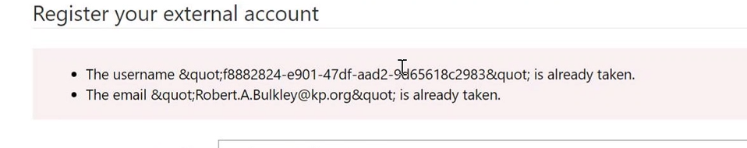
* Docs said make sure there's unique ID or email, but going in Azure AD showed the record WAS unique (roadblock)
* Rafale noted that user aadded to env as portal contact so trying to reg. againt causes issue
* First time registering, assoc. object ID and email of azure AD user, trying to register again says this "already taken"
* Admin Center > Env > KP Mars > Apps
* At Custoemr Service Hub > Accs > Contacts
  + Checking robert buckley data in Active Contacts
  + Checking Portal Contact for GUID
    - Found at Web Authentication > Username
  + This isn't considered a user error
  + This individual went to register but didn't consider if they had already signed in
  + Check with richard? About sys admin of the portal
  + If user intends to sign in and gets "already exists" error ?
* When someone changes email, bug showed up with using new email creates same existing username
  + Might have to delete the profile and allow them to reregister
* Needs it to start exploring the to-be added sql tables
  + If data sits in a sql database, it'll write to a virtual table, within the tenant?
  + Start with SQL and then move to sharepoint
* Sharepoint would be easier to implement this
  + For a SQL table, need to setup Odata provider to have communication work, will double check if this condition was made easier

**Potential of learning and using Virtual Tables**

* Once into virtual table conv. Was announced that youd be able to build virtual table from antoher dataverse table in separate env
  + Can still consume the dataverse table from a separate environment, coming soon?
* Noted this is lower priority, backlog is currently full
* Backlog item would be to learn more about Virtual tables, KY2023?
  + Backup tables asap

Future Actions:

* Rafael is researching on-premise gateway topic, will have more next week
* Mrunmay setup intake for friday